# **Power BI Changes by Month**

|  |  |  |  |
| --- | --- | --- | --- |
| Year | Month | Video of Changes | URL of Page for Changes |
| 2015 | July |  | <https://powerbi.microsoft.com/en-us/blog/what-s-new-in-the-power-bi-desktop-ga-update/> |
| 2015 | August | <https://youtu.be/2v7LUD7MJaw> | <https://powerbi.microsoft.com/en-us/blog/announcing-the-power-bi-desktop-august-update/> |
| 2015 | September | <https://youtu.be/Jm44dLXdarQ> | <https://powerbi.microsoft.com/en-us/blog/44-new-features-in-the-power-bi-desktop-september-update/> |
| 2015 | October | <https://youtu.be/Jbocn1ZNkxM> | <https://powerbi.microsoft.com/en-us/blog/custom-visualizations-support-and-22-other-features-in-the-power-bi-desktop-october-update/> |
| 2015 | November | <https://youtu.be/ErHvpkyQjSg> | <https://powerbi.microsoft.com/en-us/blog/announcing-the-power-bi-desktop-november-update/> |
| 2015 | December | <https://youtu.be/iW5VH8iIyfE> | <https://powerbi.microsoft.com/en-us/blog/more-power-bi-feature-updates-power-bi-desktop-december-update-and-new-power-bi-service-features/> |
| 2016 | January | <https://youtu.be/ek8dwi33-24> | <https://powerbi.microsoft.com/en-us/blog/power-bi-updates-this-week-new-report-authoring-capabilities/> |
| 2016 | February | <https://youtu.be/J5gZ65Wexh4> | <https://powerbi.microsoft.com/en-us/blog/power-bi-update-lots-of-new-authoring-features-and-a-new-power-bi-desktop-update/> |
| 2016 | March | <https://youtu.be/eAayYDF9QzY> | <https://powerbi.microsoft.com/en-us/blog/power-bi-desktop-march-update-feature-summary/> |
| 2016 | April | <https://youtu.be/7IFZTYJR3Gk> | <https://powerbi.microsoft.com/en-us/blog/power-bi-desktop-april-update-feature-summary/> |
| 2016 | May | <https://youtu.be/KnDs4amt9-c> | <https://powerbi.microsoft.com/en-us/blog/power-bi-desktop-may-update-feature-summary/> |
| 2016 | June | <https://youtu.be/sZsL2l6oS4A> | <https://powerbi.microsoft.com/en-us/blog/power-bi-desktop-june-update/> |
| 2016 | July | <https://youtu.be/g8ccfjffWmw> | <https://powerbi.microsoft.com/en-us/blog/power-bi-desktop-july-feature-summary/> |
| 2016 | August | <https://youtu.be/0VvG7Eqoke8> | <https://powerbi.microsoft.com/en-us/blog/power-bi-desktop-august-feature-summary/> |
| 2916 | September | <https://youtu.be/pcUr6E8g_KI> | <https://powerbi.microsoft.com/en-us/blog/power-bi-desktop-september-feature-summary/> |
| 2016 | October | <https://youtu.be/UXEYSvgvMaQ> | <https://powerbi.microsoft.com/en-us/blog/power-bi-desktop-october-feature-summary/> |
| 2016 | November | <https://youtu.be/kERJ_WOLuLk> | <https://powerbi.microsoft.com/en-us/blog/power-bi-desktop-november-feature-summary/> |
| 2016 | December | No New Features This Month | <https://powerbi.microsoft.com/en-us/blog/power-bi-desktop-2016-year-in-review/> |
| 2017 | January | <https://youtu.be/C1-f0T8vZ7M> | <https://powerbi.microsoft.com/en-us/blog/power-bi-desktop-january-feature-summary/> |
| 2017 | February | <https://youtu.be/mn75-LOPxMA> | <https://powerbi.microsoft.com/en-us/blog/power-bi-desktop-february-feature-summary/> |
| 2017 | March | <https://youtu.be/CaRTON3lJqw> | <https://powerbi.microsoft.com/en-us/blog/power-bi-desktop-march-feature-summary/> |
| 2017 | April | <https://youtu.be/AWMaIaI8G2Y> | <https://powerbi.microsoft.com/en-us/blog/power-bi-desktop-april-feature-summary/> |
| 2017 | May | <https://youtu.be/CKISVNHcHVA> | <https://powerbi.microsoft.com/en-us/blog/power-bi-desktop-may-feature-summary/> |
| 2017 | June | <https://youtu.be/YlNVE5dgcSI> | <https://powerbi.microsoft.com/en-us/blog/power-bi-desktop-june-feature-summary/> |
| 2017 | July | <https://youtu.be/4X96ow7FnSY> | <https://powerbi.microsoft.com/en-us/blog/power-bi-desktop-july-feature-summary-2/> |
| 2017 | August | <https://youtu.be/ND8U0yXroaQ> | <https://powerbi.microsoft.com/en-us/blog/power-bi-desktop-august-2017-feature-summary/> |
| 2017 | September | <https://youtu.be/moTQJlnClJw> | <https://powerbi.microsoft.com/en-us/blog/power-bi-desktop-september-2017-feature-summary/> |
| 2017 | October | <https://youtu.be/jksjtR8GnBE> | <https://powerbi.microsoft.com/en-us/blog/power-bi-desktop-october-2017-feature-summary/> |
| 2017 | November | <https://youtu.be/sI3yRjdnJ7w> | <https://powerbi.microsoft.com/en-us/blog/power-bi-desktop-november-2017-feature-summary/> |
| 2017 | December | <https://youtu.be/ZPU8B-1BxjI> | <https://powerbi.microsoft.com/en-us/blog/power-bi-desktop-december-feature-summary/> |
| 2018 | January | <https://youtu.be/W8Pp5wuCXJw> | <https://powerbi.microsoft.com/en-us/blog/power-bi-desktop-january-2018-feature-summary/> |
| 2018 | February | <https://youtu.be/KeVB5RwMzJo> | <https://powerbi.microsoft.com/en-us/blog/power-bi-desktop-february-2018-feature-summary/> |
| 2018 | March | <https://youtu.be/kuI6MMzDh34> | <https://powerbi.microsoft.com/en-us/blog/power-bi-desktop-march-2018-feature-summary/> |

# Other Related Links:

|  |  |
| --- | --- |
| Create Impactful Reports: | <https://youtu.be/d2bZpNZ6uIA> |
| Analyzing and Visualizing Data with Power BI: | <https://youtu.be/1c01r_pAZdk> (Course includes 148 videos starting here) |
| Introduction to Color Theory: | <http://www.tigercolor.com/color-lab/color-theory/color-theory-intro.htm> |
| Power BI Quick Measures Gallery: | <https://community.powerbi.com/t5/Quick-Measures-Gallery/bd-p/QuickMeasuresGallery> |
| Power BI Theme Gallery: | <https://community.powerbi.com/t5/Themes-Gallery/bd-p/ThemesGallery> |
| Color Contrast Analyzer: | <https://developer.paciellogroup.com/resources/contrastanalyser/> |
| Adobe Color CC: | <https://color.adobe.com/create/color-wheel/> |
| Theme Master 500: | <http://paletton.com/#uid=1000u0kllllaFw0g0qFqFg0w0aF> |
| Create Report Color Themes: | <https://powerbi.tips/tools/report-theme-generator-v3/> |
| How to Create Stunning Visual Reports: | <https://youtu.be/rS8xmkoasQU> |
| Interactive Chart Selector: | <https://community.powerbi.com/t5/Data-Stories-Gallery/Choose-your-power-bi-chart/m-p/34319> |
| ArcGIS Maps for Power BI: | <http://doc.arcgis.com/en/maps-for-powerbi/design/specify-location-type.htm> & <https://powerbi.microsoft.com/en-us/blog/announcing-arcgis-maps-for-power-bi-by-esri-preview/> |

# Details of Power BI Changes

## 

Back to Top

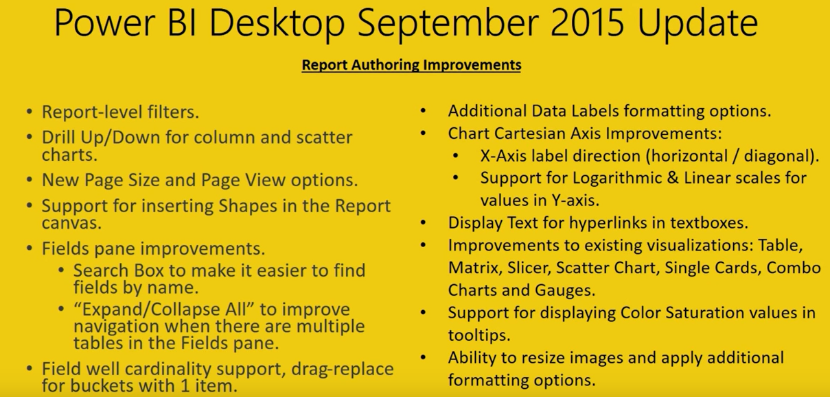

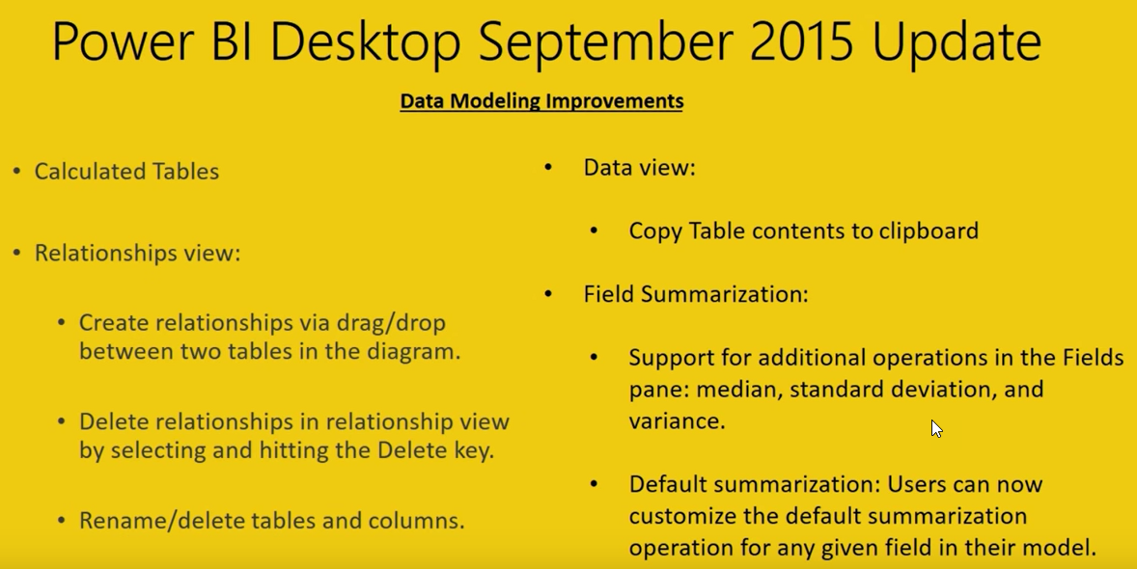

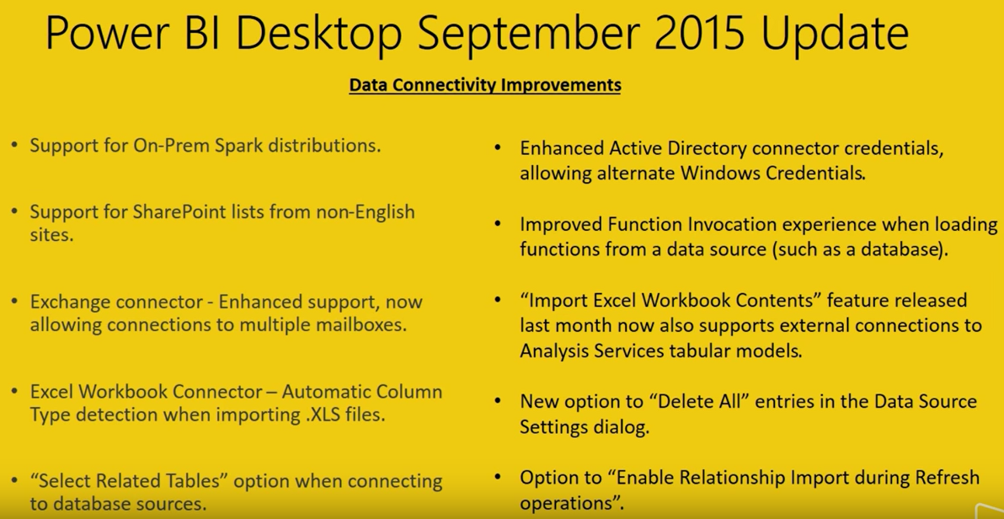

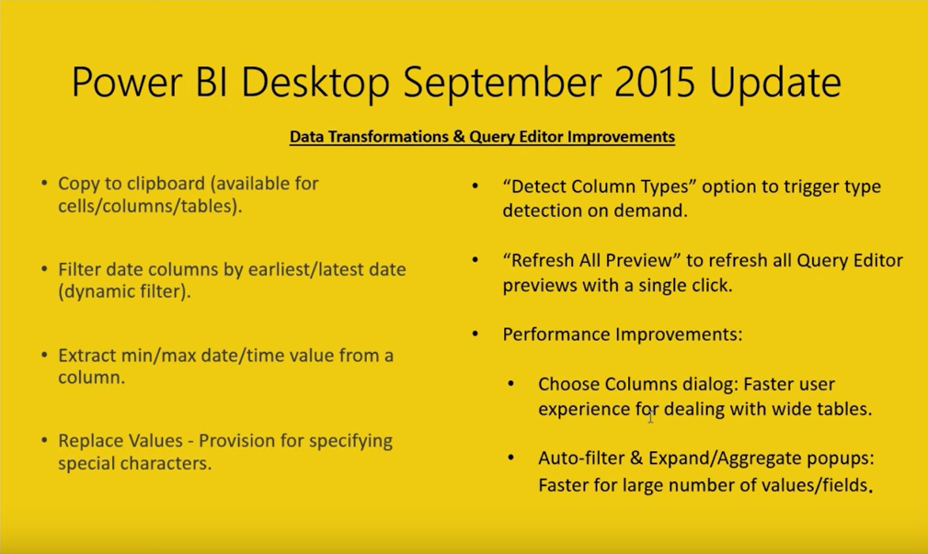

Back to Top

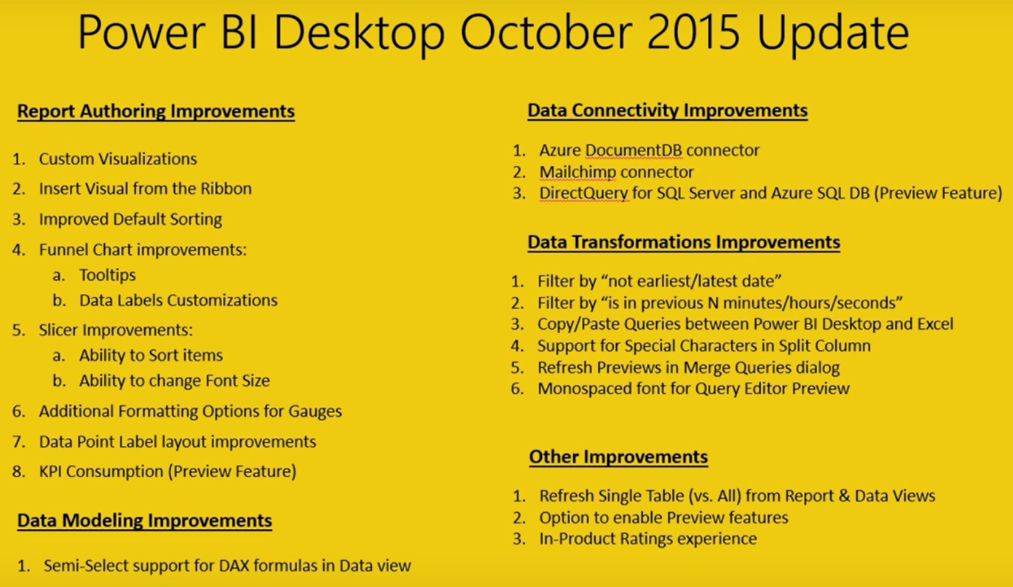

Back to Top

## November 2015

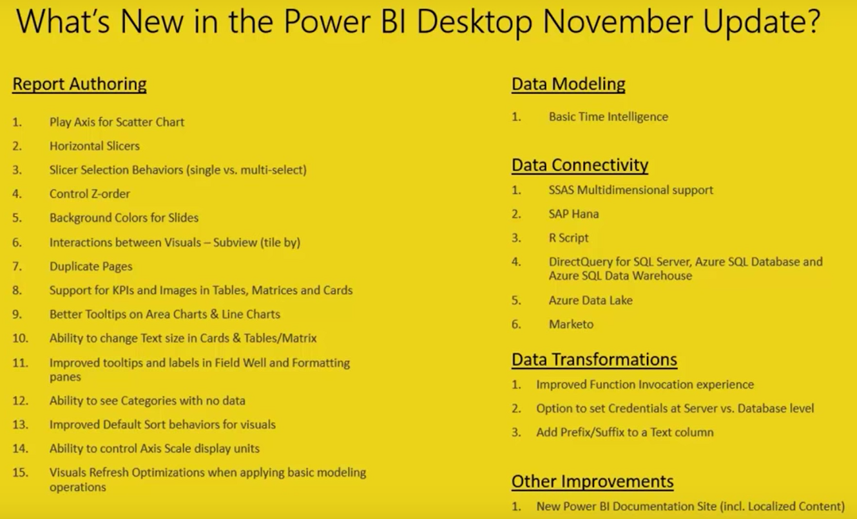

Back to Top

## December 2015

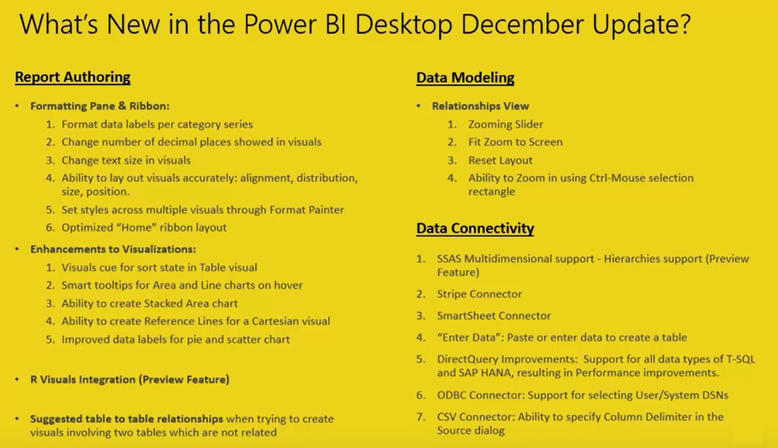

Back to Top

## January 2016

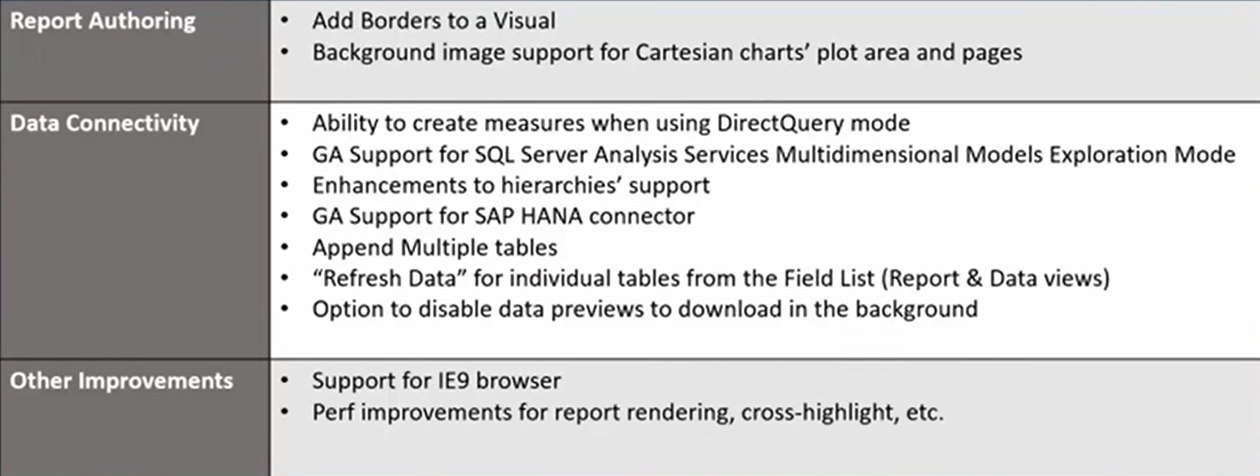

Back to Top

## February 2016

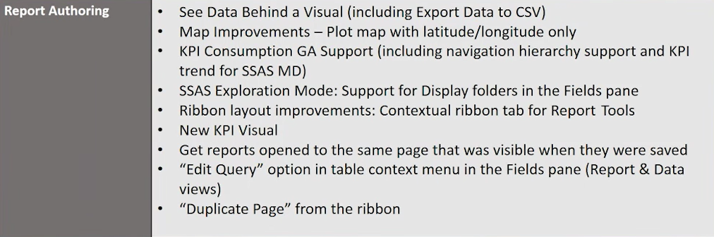



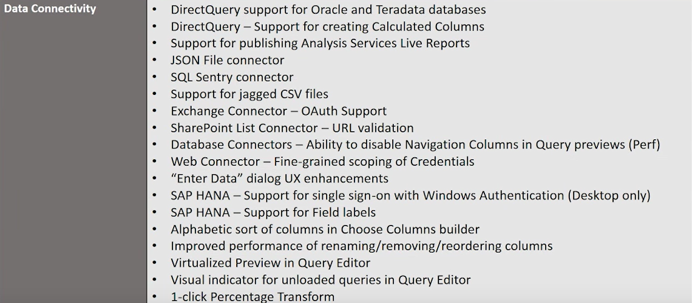

Back to Top

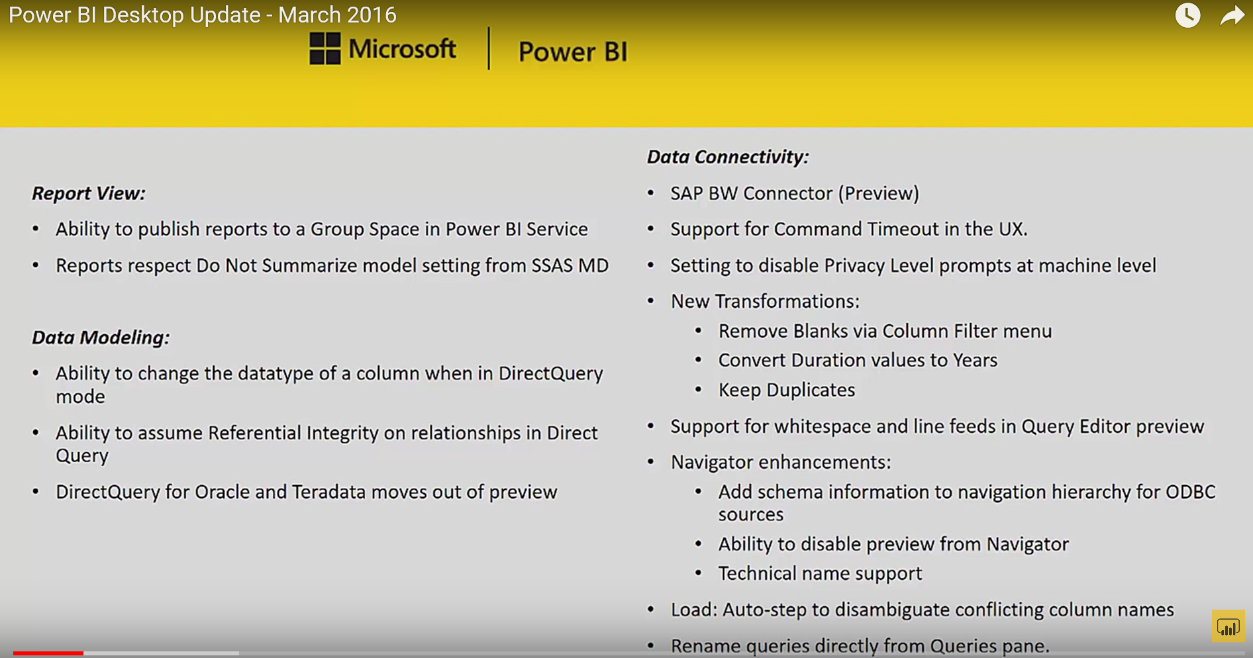

Back to Top

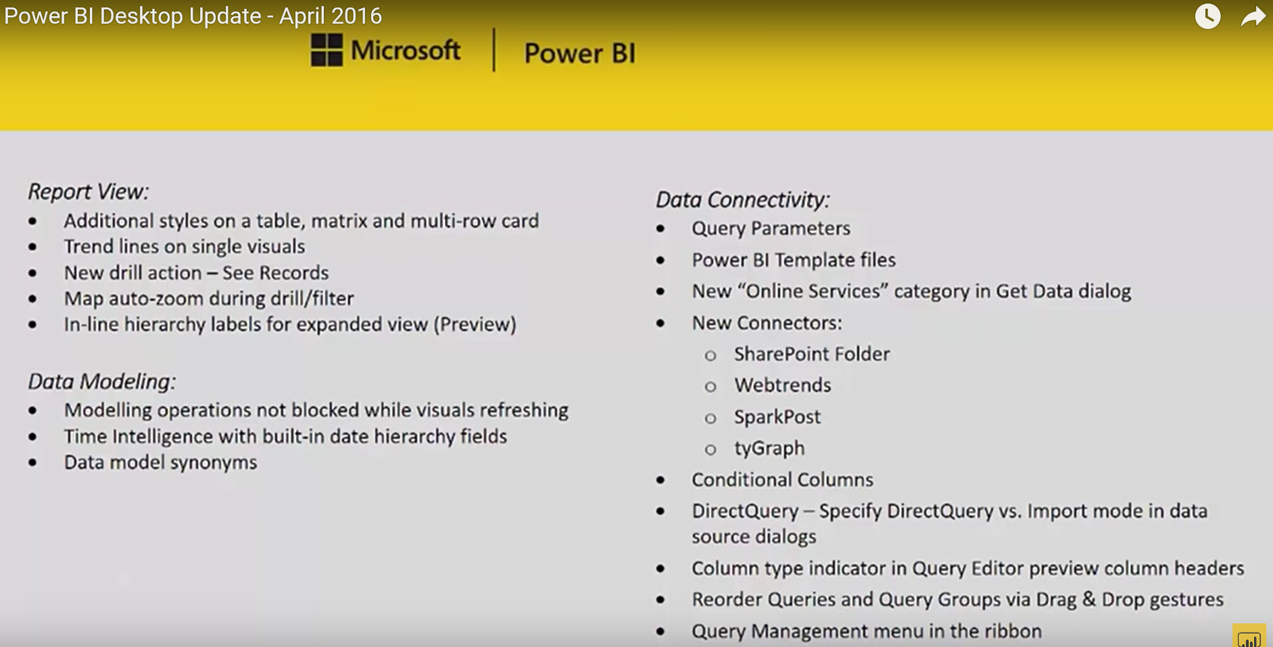

Back to Top

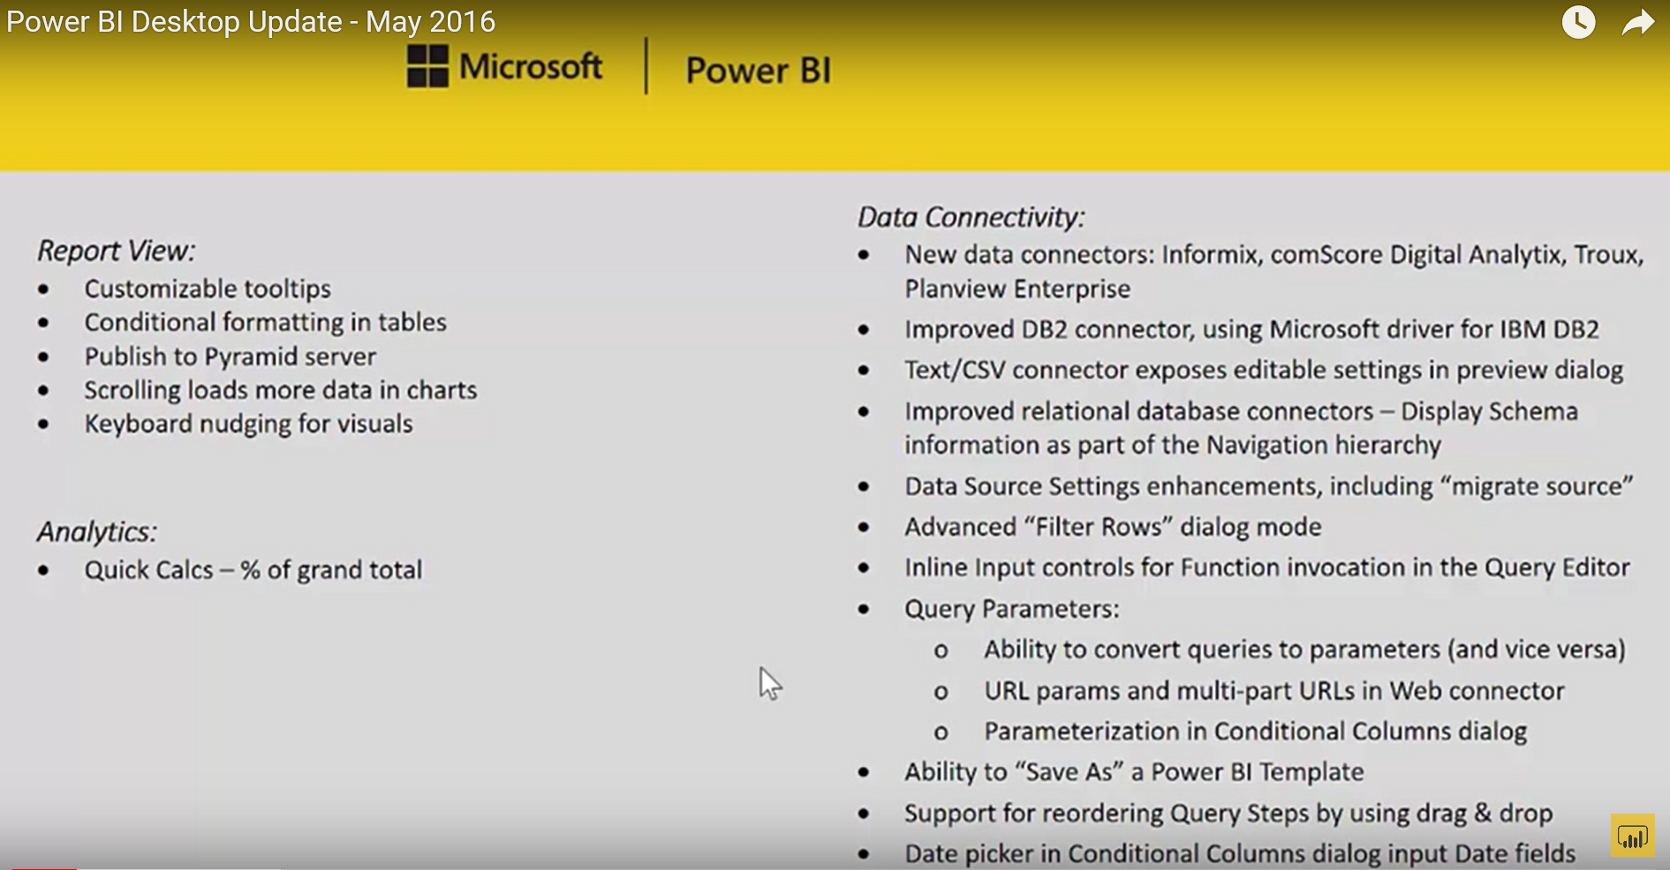

Back to Top

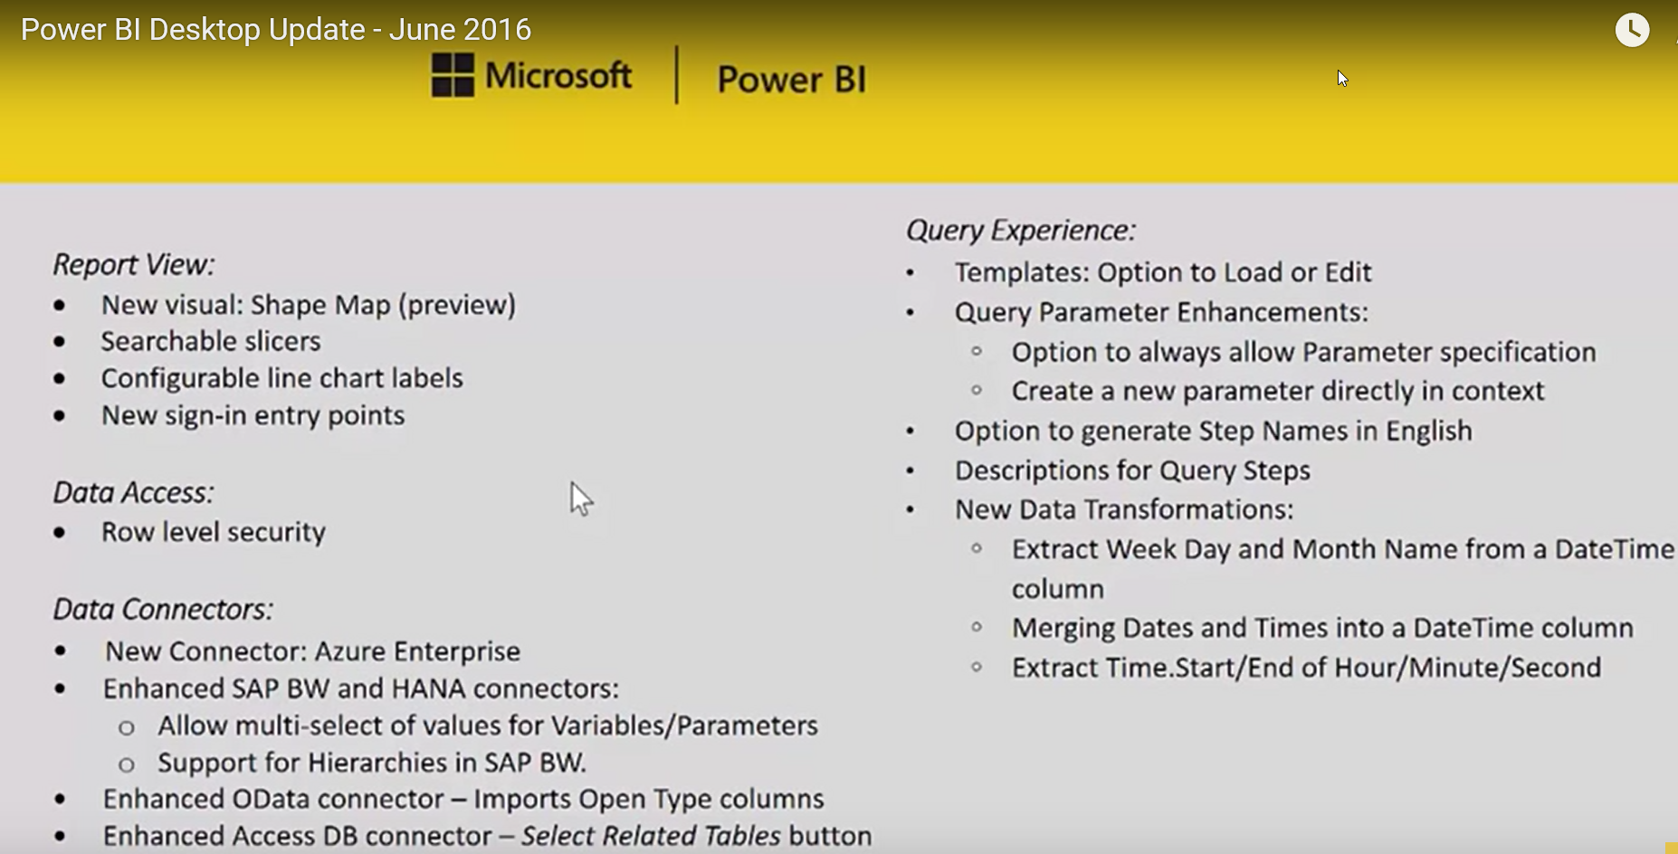

Back to Top

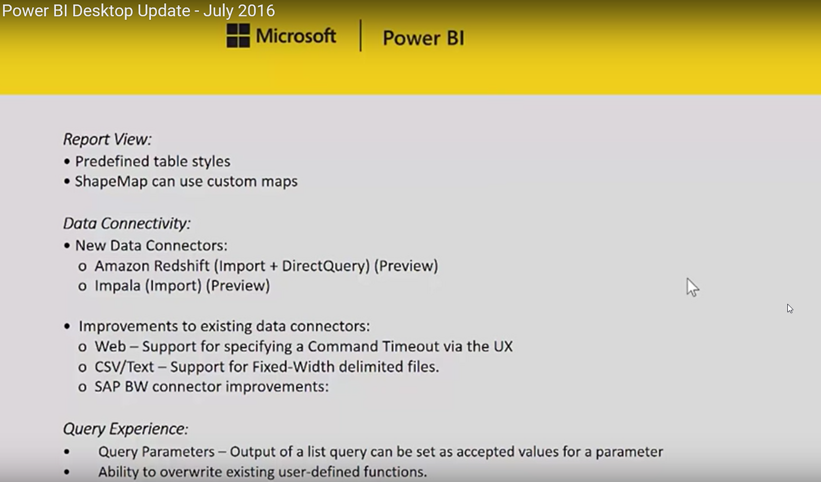

Back to Top

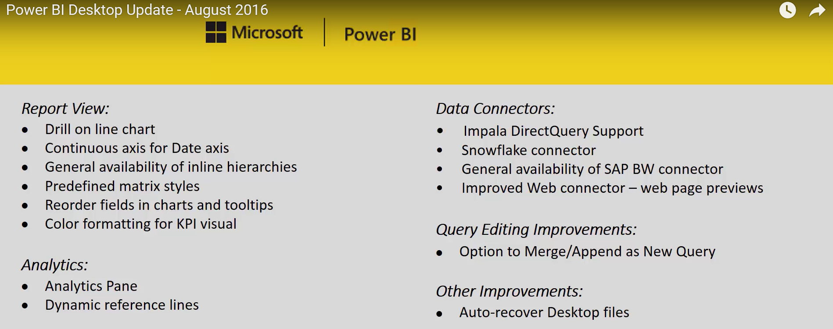

Back to Top

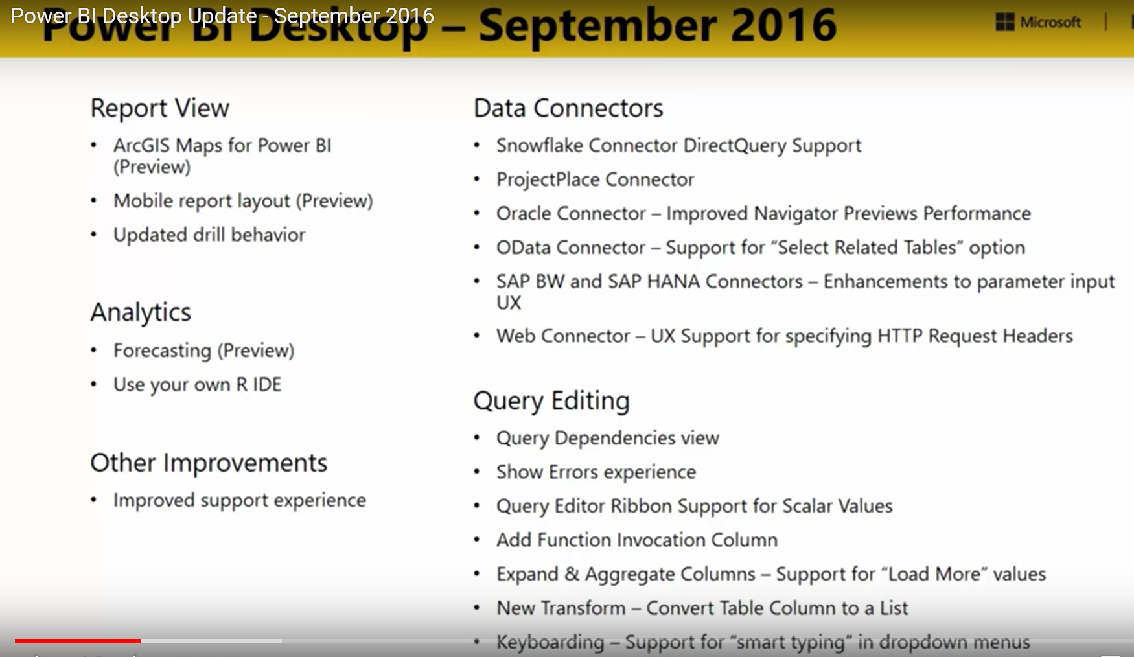

Back to Top

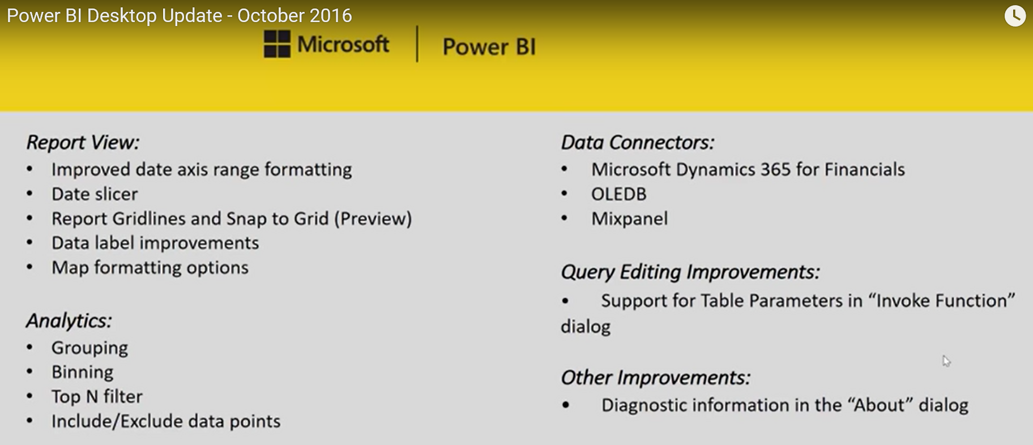

Back to Top

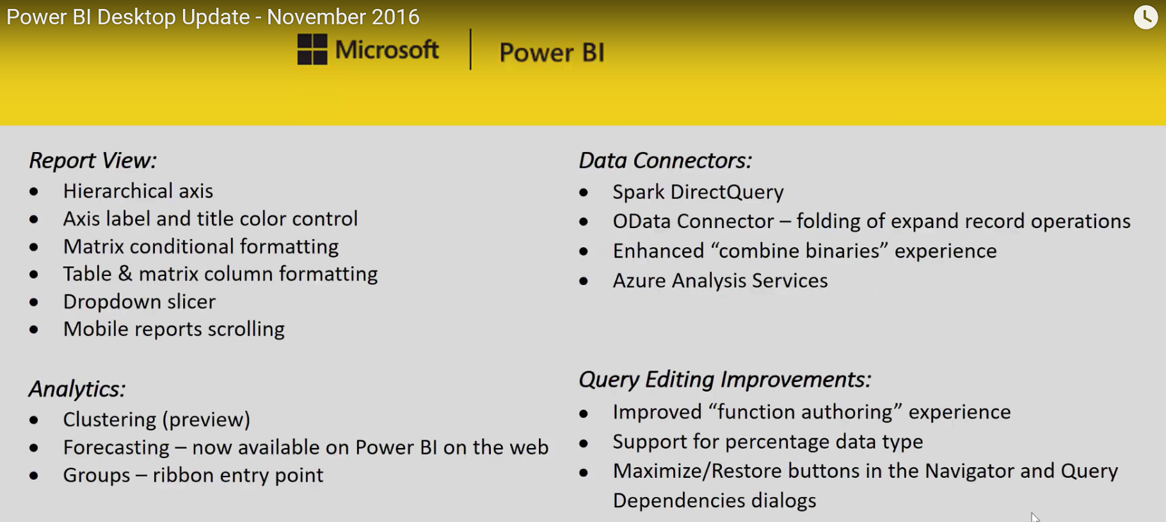

Back to Top

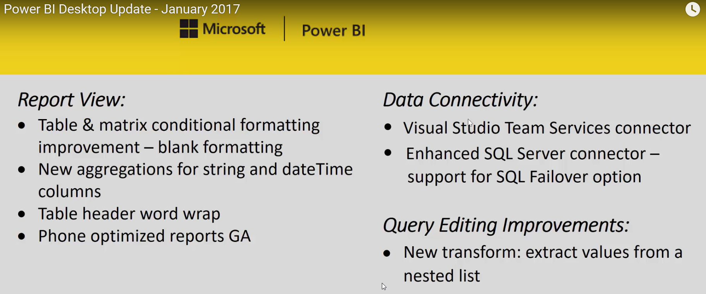

Back to Top

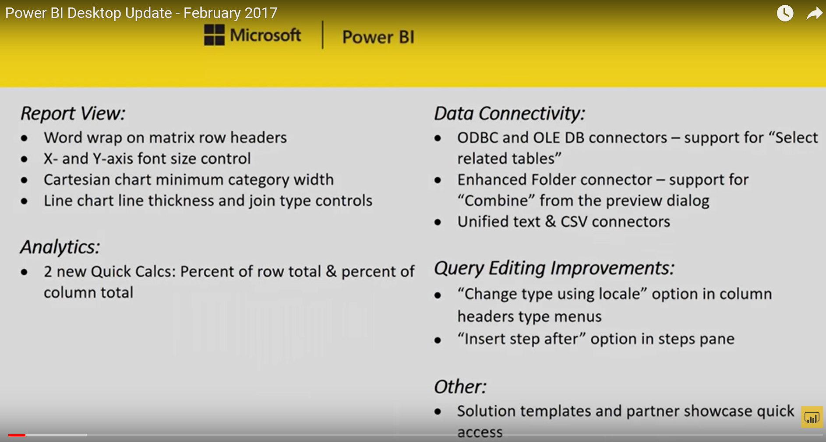

Back to Top

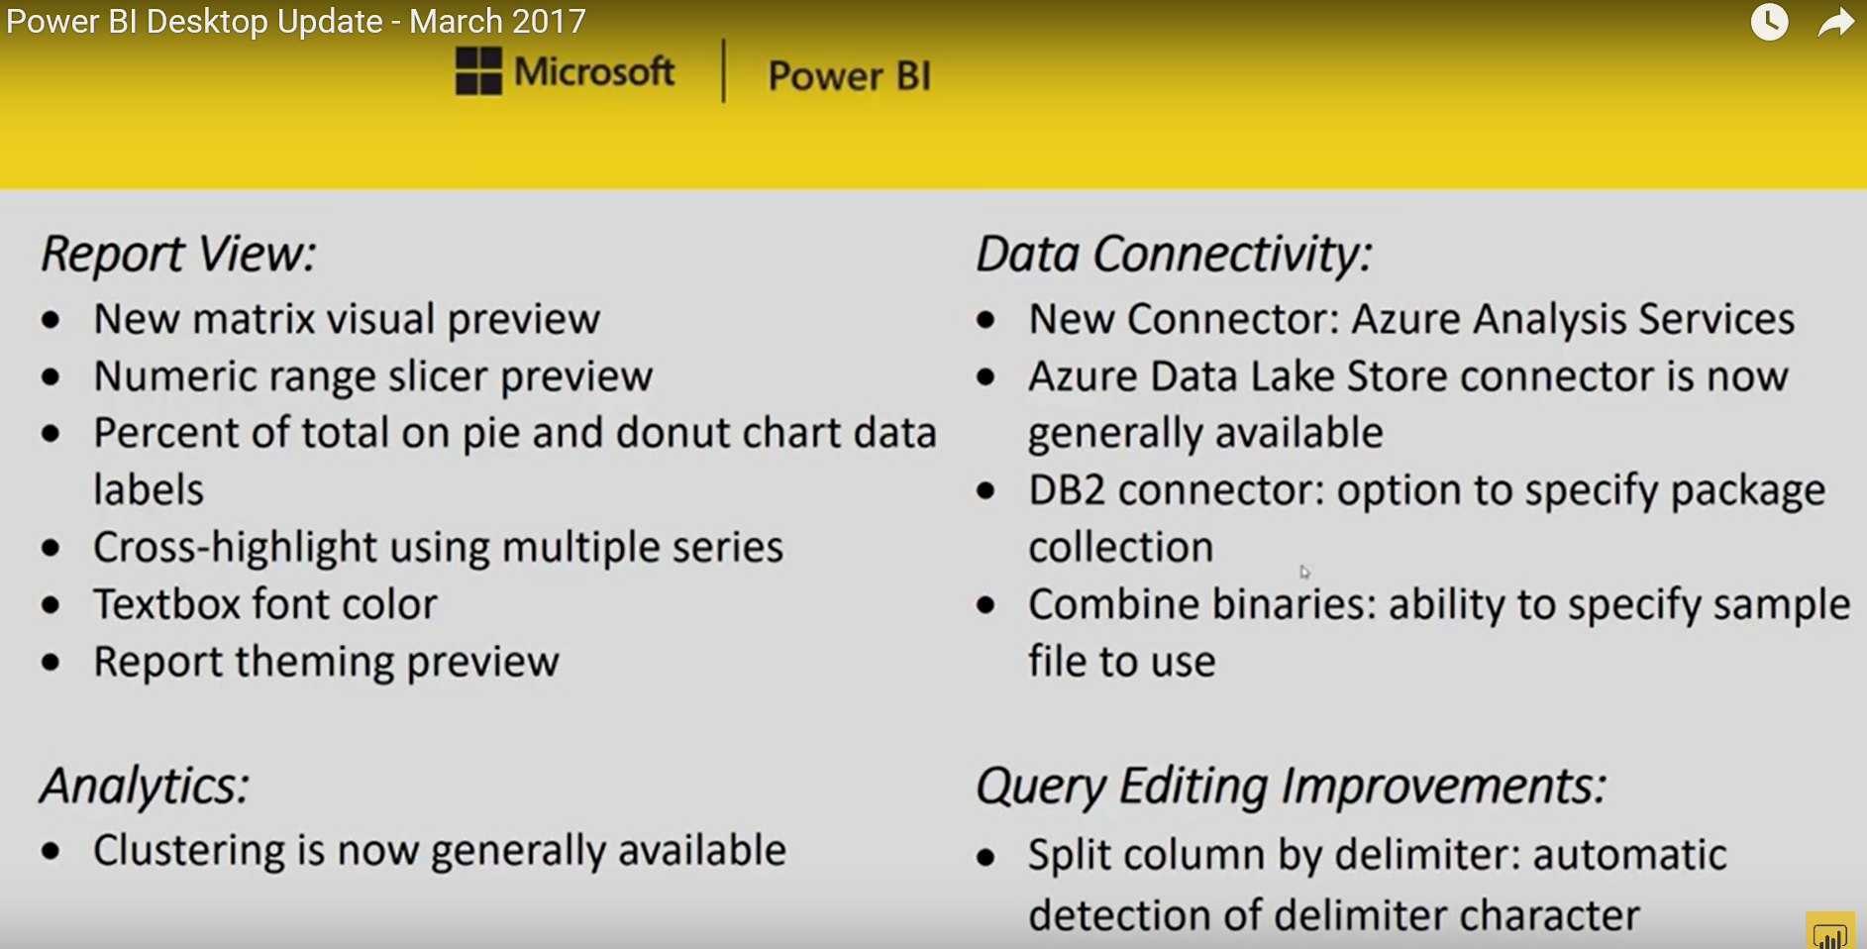

Back to Top

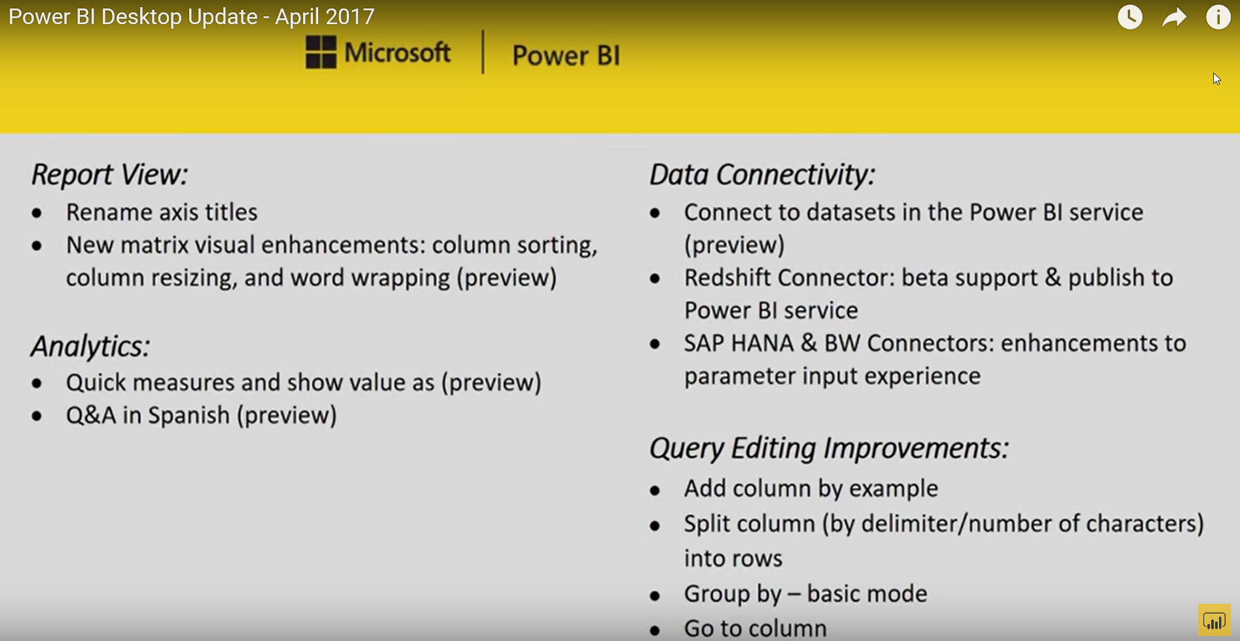

Back to Top

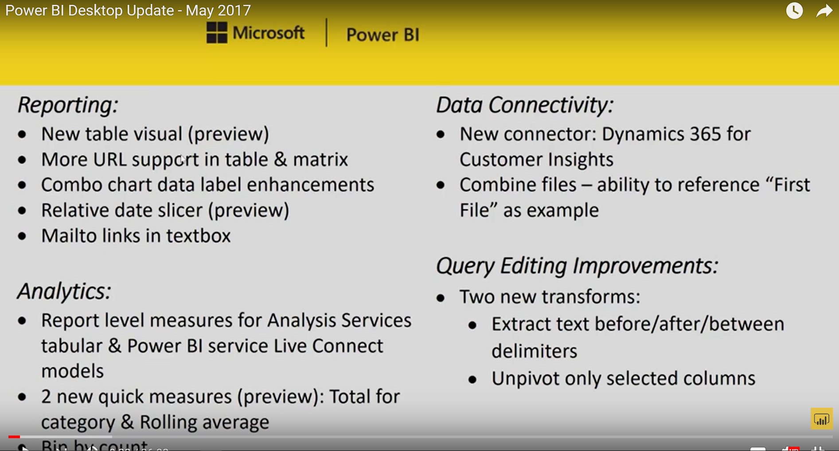

Back to Top

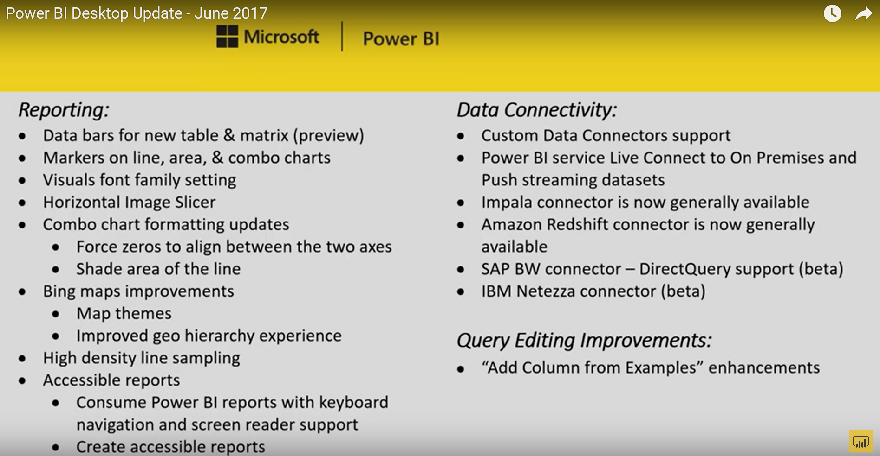

Back to Top

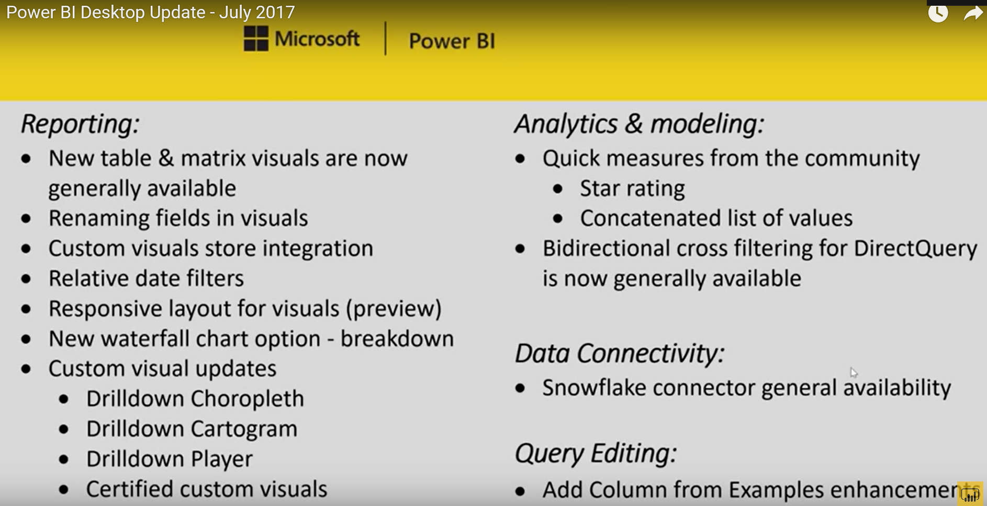

Back to Top

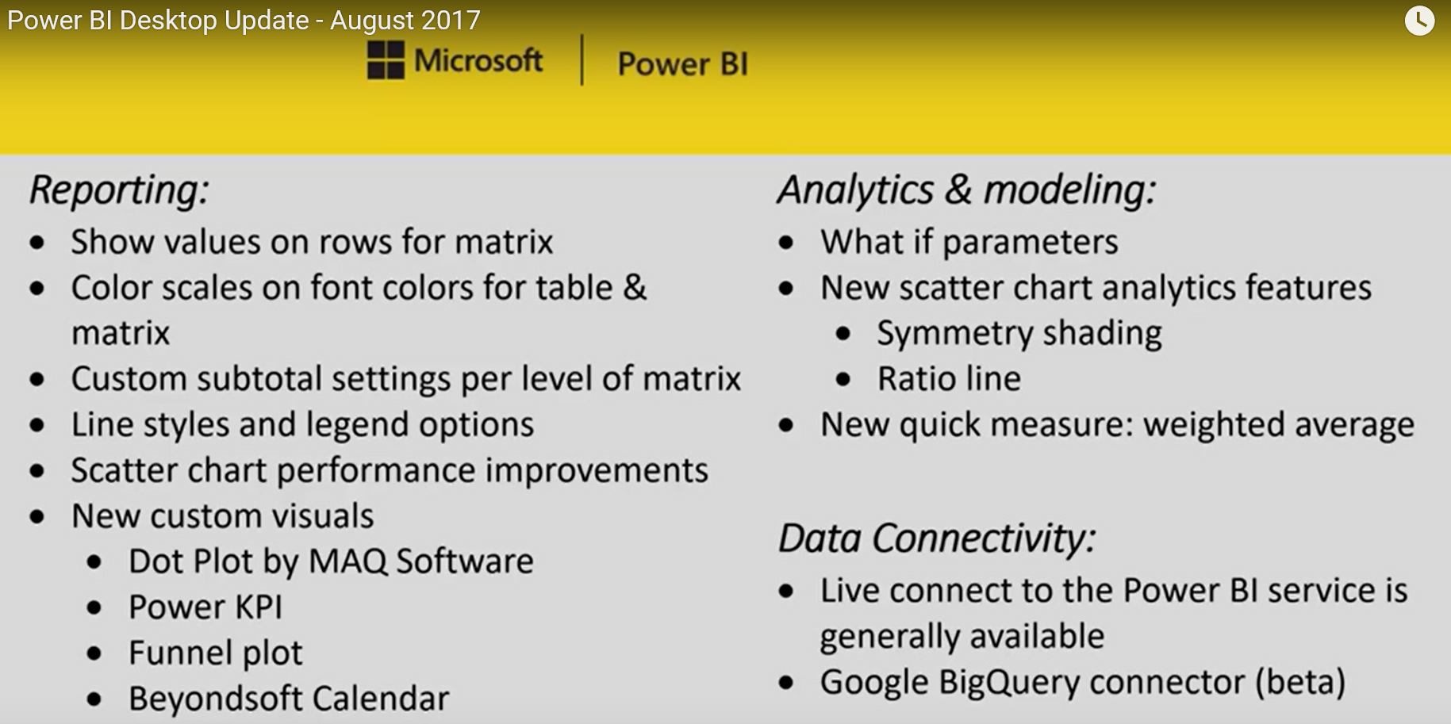

Back to Top

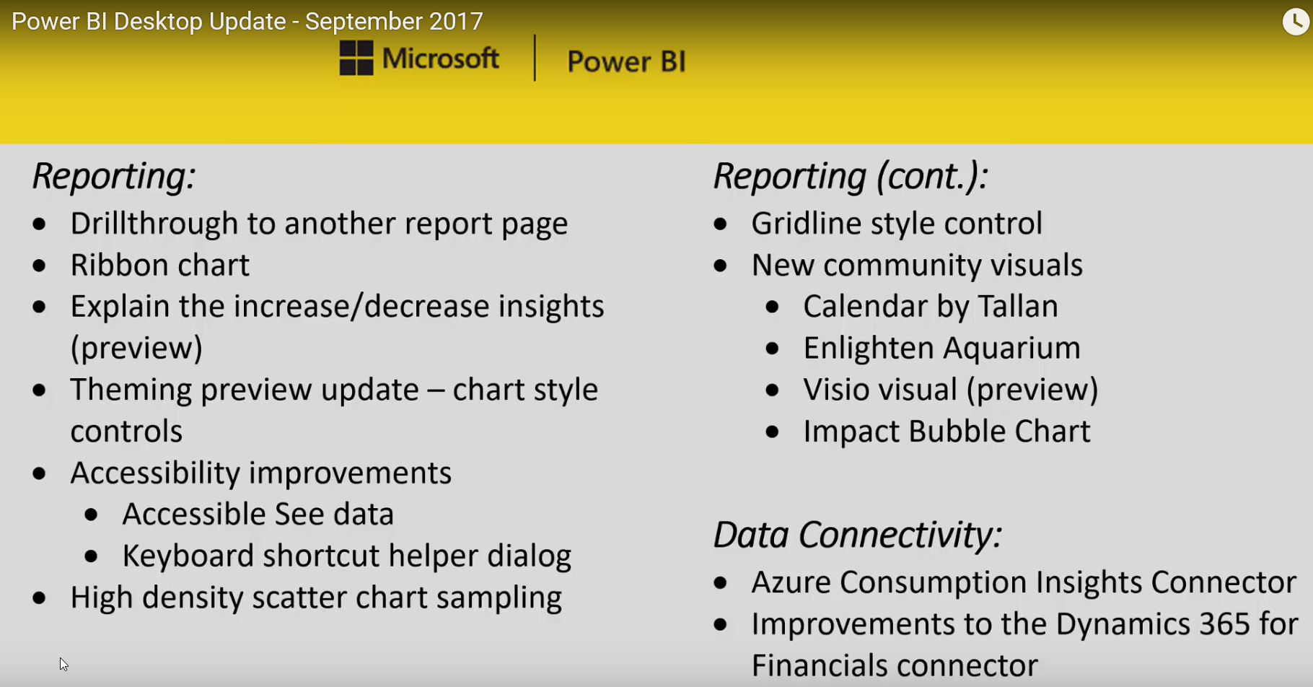

Back to Top

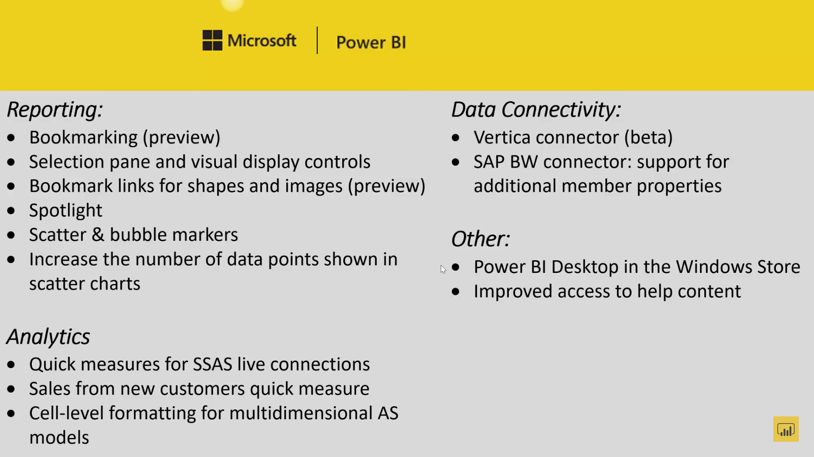

Back to Top

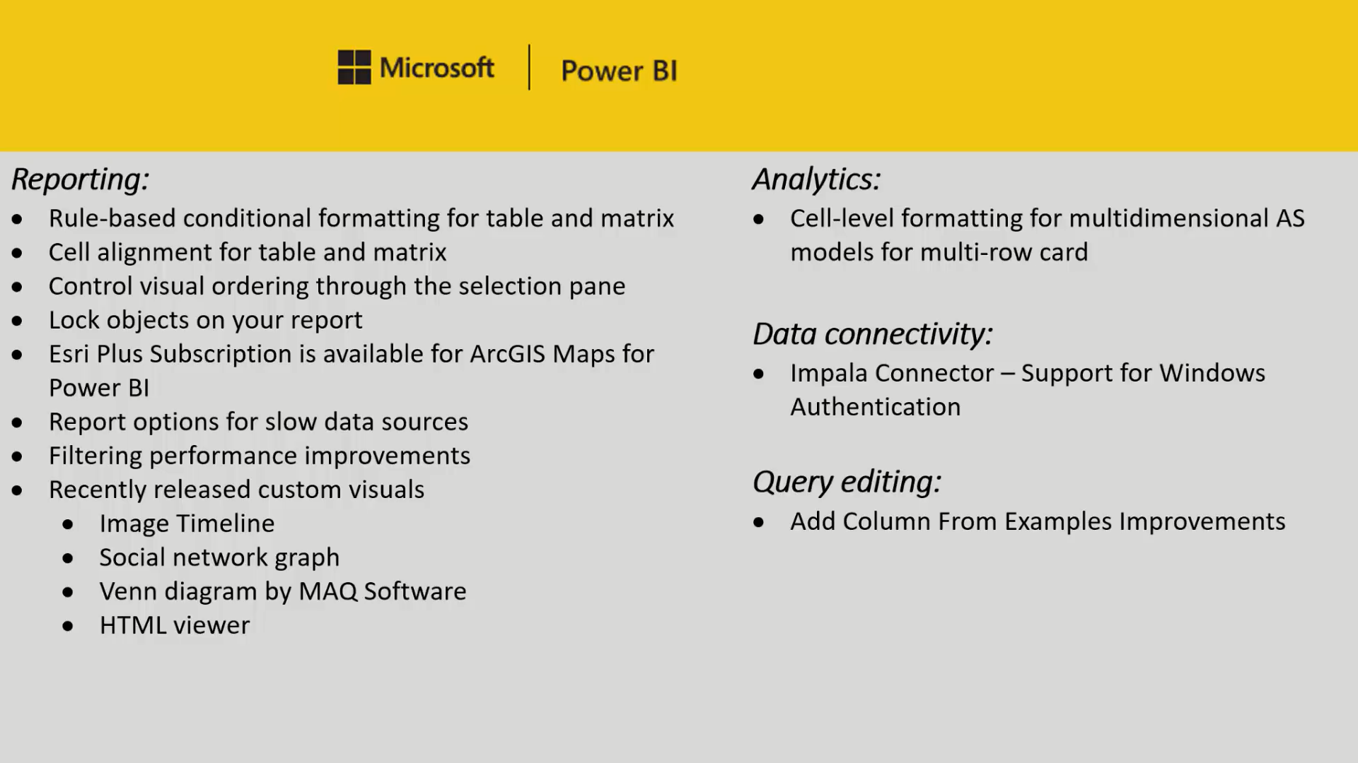

Back to Top

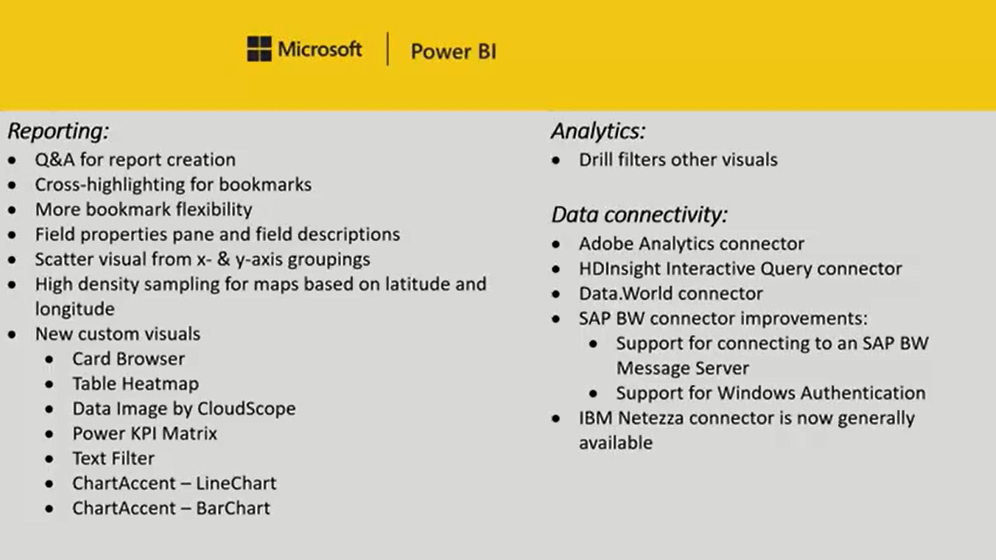

Back to Top

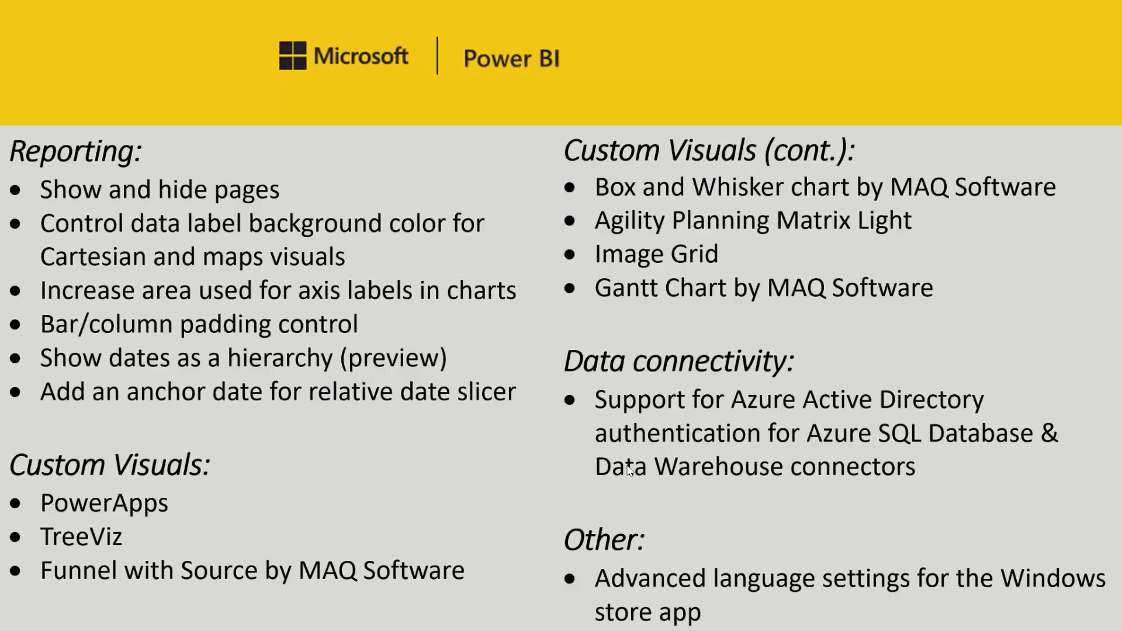

Back to Top

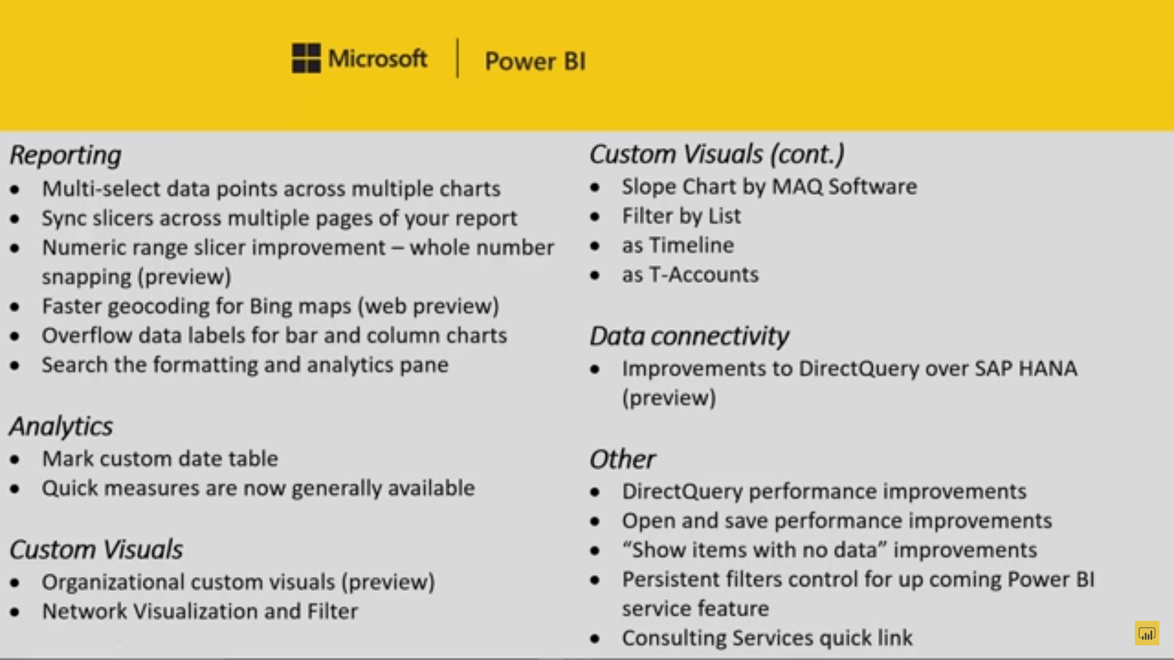

Back to Top

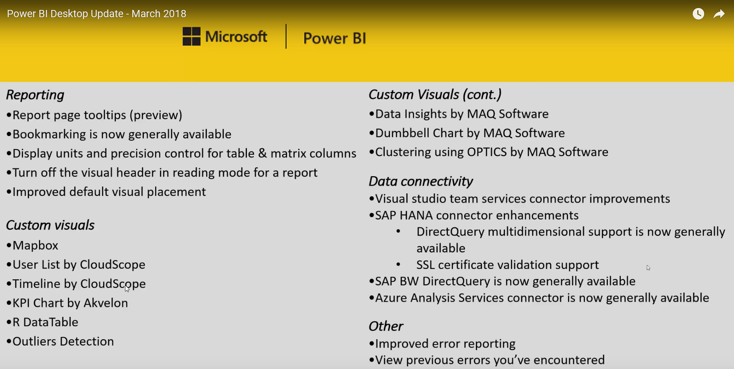

Back To Top